

**Tribhuvan University**

**Faculty of Humanities and Social Science**

**A PROJECT REPORT On**

**" Lifestyle Store "**

**Submitted to**

**Department of Information Technology**

**Kathford International College of Engineering and Management Balkumari, Lalitpur**

***In partial fulfilment of the requirements for the Bachelors in Computer Application***

**Submitted by**

**Sohesh Maharjan (6-2-456-33-2020)**

**Under Supervision of**

**Ishwar Dhungana**

**March 2024**

# ABSTRACT

“Lifestyle Store” is an e-commerce website where a user can find clothing products at a convenient price with good customer service. This website is based on online payment system. This website is easy to use and has elaborative product description. The purpose of this website is to help customers to provide a wide range of latest fashion wear products such as shoe, shirt, t-shirt at affordable prices. To develop this project iterative method is used. This website is made with a scripting language like JavaScript which is assisted by CSS and PHP at the backend.

***Keywords: Clothing , STORE, e-commerce website, online payment***

# ACKNOWLEDGEMENT

We take this opportunity to express my deepest and sincere gratitude to our **Supervisor Ishwar Dhungana** for his insightful advice, motivating suggestions, invaluable guidance, help and support in successful completion of this project and also for his constant encouragement and advice throughout our Bachelors program.

We express our deep gratitude to **Head of Computer department, Mukesh Chaudhary** for his indispensable guidance and support to harness our skills. The in-time facilities provided by the department throughout the Bachelors program are also equally acknowledgeable.

We would like to convey our thanks to the teaching and non-teaching staff of the **Department of Computer Application** for their invaluable help and support throughout the period of Bachelor’s Degree. We are also grateful to all our classmates for their help, encouragement and invaluable suggestions.

Finally, yet more importantly, I would like to express my deep appreciation to my parents for their perpetual support and encouragement throughout the Bachelor’s degree period.

**Table of Contents**

ABSTRACT i

ACKNOWLEDGEMENT ii

LIST OF TABLES v

LIST OF FIGURES vi

LIST OF ABBREVIATIONS vii

CHAPTER ONE: INTRODUCTION 1

1.1 Introduction 1

1.2 Problem Statement 1

1.3 Objective 1

1.4 Scope and Limitation 1

1.5 Report Organization 2

CHAPTER TWO: BACKGROUND STUDY AND LITERATURE REVIEW 3

2.1 Background Study 3

2.2 Literature Review 3

CHAPTER THREE: SYSTEM ANALYSIS AND DESIGN 4

3.1 System Analysis 4

3.1.1 Requirement Analysis 4

3.1.2 Methodology of the proposed system 6

3.1.3 Feasibility study 6

3.1.4 Data Modeling (Entity Relationship diagram) 7

3.2 System Design 8

3.2.1 Architectural Design 8

3.2.2 Database Schema Design 9

3.2.3 User Interface Design 9

CHAPTER FOUR: IMPLEMENTATION AND TESTING 10

4.1 Implementation 10

4.1.1 Tool Used 10

4.2 Testing 12

4.2.1 Test cases for Unit Testing 12

4.2.2 Test Cases for System Testing 13

CHAPTER FIVE: CONCLUSION AND FUTURE RECOMMENDATIONS 14

5.1 Conclusion 14

5.2 Future Recommendation 14

References 15

Appendices 16

# LIST OF TABLES

Table 1: Test for Failed User Registration (Wrong email format) .................................... 12

Table 2: Test for Failed User Registration (Unmatching Password) ................................ 12

Table 3: Test for Successful User Registration.................................................................. 12

Table 4: Test for Successful User Login............................................................................ 13

Table 5: Test for Failed User Login (Wrong password or email) ...................................... 13

Table 6: Test for the whole System ................................................................................... 13

# LIST OF FIGURES

Figure 1: Use Case Diagram of Lifestyle Store ……..................................................... 5

Figure 2: Agile Method ................................................................................................... 6

Figure 3: Gantt Chart of Lifestyle Store …………......................................................... 7

Figure 4: ER Diagram of Lifestyle Store …………........................................................ 8

Figure 5: Database Schema for Lifestyle Store…………................................................ 9

Figure 6: UI Design of Lifestyle Store ............................................................................ 9

Figure 7: SFD of Lifestyle Store .................................................................................... 11

Figure 8: Home Page ...................................................................................................... 16

Figure 9: Cart ………...................................................................................................... 16

Figure 10: User Login ..................................................................................................... 17

# LIST OF ABBREVIATIONS

CSS: Cascading Style Sheet.

DFD: Data Flow Diagram.

HTML: Hyper Text Markup Language.

PHP: Hypertext Preprocessor.

SQL: Structured Query Language.

# CHAPTER ONE: INTRODUCTION

## Introduction

The project **Lifestyle Store** has been developed on HTML,PHP, CSS, Java Script amd My SQL. An online shopping store which allow formal and informal merchants in developing countries to advertise and sell their good on the internet. This would permit rural communities to make their wears available to the rest of the world via World Wide Web. The objective of this project is to create an e-commerce web portal with a content management system which allow product information to be updated securely using a mobile device. The web portal will have an online interface in the form of an e-commerce website that allow users to buy goods from the merchants.

Similarly, on the user interface, customers can see products with descriptions. The section like categories help user view product with ease. Users can easily order by adding the necessary products in the cart.

Design of this is so simple that the user won’t find difficulties while working on it. The main goal of this project is to make shopping experience easy.

## 1.2 Problem Statement

## As online shopping has become a trend nowadays regular shops are losing their customers to online brands. Customers have an effortless shopping experience and save time through shopping online. For competing with those online brands , If shops are providing an onlineportal where their customers can shop through internet and get the products at their doors it will increase the number of customers.

The objective is as follows:

* To make shopping easier and more comfortable
* To serve the customers without wasting their precious time

## 1.4 Scope and Limitation

The major motive behind developing the website is to help people shop clothing product with ease and convenience. The final product is a web- based application that has different categories and various product. Our website help for secure registration and profile management facilities for user so that unauthorized use cannot use your . The website will make shopping experience of customer easy.

**Limitation**

* Service delivery is not provided.

## 1.5 Report Organization

The report is organized into five chapters under major headings, explaining about the system.

**Chapter- 1 Introduction**

This section describes the basic of system’s objective, scope, limitations and problem statement.

**Chapter-2 Background study and Literature review**

This section describes the “background study” of the website we developed. It also described the “literature review” done before the development of the system.

**Chapter-3 System analysis and design**

This part summarizes the system design and the analysis of the system. This chapter includes requirement analysis and feasibility analysis of the system. Along with this it also shows different diagrams that describe the workflow of the system.

**Chapter-4 Implementation and testing**

This section provides an account of the tools used for the development of the system. This also explains the different types of testing carried out during and after the development of the website.

**Chapter-5 Conclusion and Future Recommendation**

This chapter compiles the limitations of the website. It also has an account of what limitations the system has. Future recommendations and enhancements are also included in this chapter.

# CHAPTER TWO: BACKGROUND STUDY AND LITERATURE REVIEW

## 2.1 Background Study

In this new era of generation, the numbers of people shopping online has increased significantly throughout the year which give the greater impact to business world. This innovation for shopping not only brings a great number and variety of merchandise to potential consumers, but also offers a numerous business activities and huge market. Social media is no longer known only as a media that facilitates its users to present themselves on the internet but also as media to sell some products to consumers known as an online shop. Because of the numerous advantages and benefits, more people say that they prefer online shopping over conventional shopping these days. Through online shopping, everyone has easy access to information, various selection, low price, personal attentions.

## 2.2 Literature Review

The growing number of online clothing website which provides a great way to increase employment to many people. There are multiple such websites available in Nepal. One of them is:

##### SHEIN

SHEIN is a global fashion and lifestyle online retailer committed to making the beauty of fashion accessible to all. We use on-demand manufacturing technology to connect suppliers to our agile supply chain, reducing inventory waste and enabling us to deliver a variety of affordable products to customers around the world. From our global offices, we reach customers in more than 150 countries [1].

# CHAPTER THREE: SYSTEM ANALYSIS AND DESIGN

## 3.1 System Analysis

System analysis is conducted for the purpose of studying a system or its parts to identify its objectives. It is a problem-solving technique that improves the system and ensures that all the components of the system work efficiently to accomplish their purpose. The large complex project was broken into small manageable parts so each may be designed, studied, and analyzed in detail.

#### 3.1.1 Requirement Analysis

Requirement analysis is the crucial step for determining the success of the system or software project. Requirements are generally split into two types: functional and non-functional.

***Functional Requirement:***

Functional requirements for a system describe system behavior and focus on the needs of the users to accomplish their tasks. It provides the requirement overview of the system.

* Registration
* Login and Logout
* Browse Products
* Buy product

##### Use case diagram

The system consists of two actors: Admin and User. The user and admin login into the system. The user can view the item, add to cart and order it online. On the other hand, the admin can manipulate information. The use case diagram is shown in Figure 1:

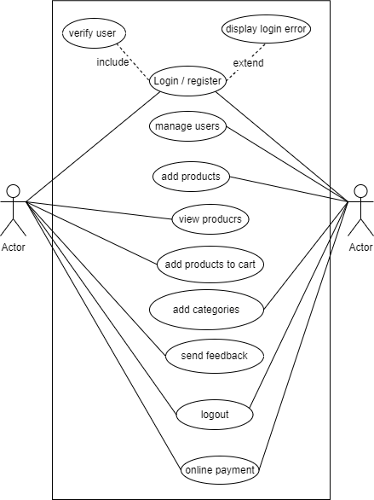

###### Figure 1: Use Case Diagram of Lifestyle Store

***Non-Functional Requirement:***

Non-functional requirements are an essential aspect of designing any website. Here are some of non-functional requirements that are considered when designing an online clothing website:

* Ease of use.
* This system will be secure.
* It will be reliable for the user.
* Information in fields like phone numbers, email, names are validated.
* This system will be designed for smooth performance.

#### 3.1.2 Methodology of the proposed system

After examining the task requirements, the following stage is to evaluate the problem and comprehend its context. The first action in the phase is to research about the system, while the second is to comprehend the requirements and domain of the new system.

Agile Methodology was employed in the creation of this system. The Agile methodology is a style of project management that divides projects into phases. It entails ongoing engagement with stakeholders and continuous improvement at every stage. During the development process, tasks were separated into short time spans in order to deliver certain features for a release. The key reason for selecting Agile methodology was that it enables flexible reactions to change. The methodology allowed this project to adapt to changing requirements during the development phase.

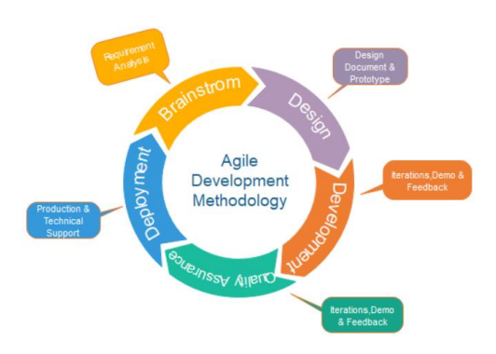

###### Figure 2: Agile Methodology

#### 3.1.3 Feasibility study

The feasibility study aims to identify the system's shortcomings and strengths, as well as the dangers and possibilities that exist in the environment. If the project's resources are available and its chances of success.

i. Technical feasibility

The website can be technically feasible because the technical requirements one needs for the development are easily available. A device where a local host server is available will easily run this system.

ii. Economic feasibility

The development of this website does not need any startup capital. Availability of a working device (desktop or laptop) and Wi-Fi would be enough to work on this as the software used is freely available.

iii. Operational feasibility

The website has a simple interface due to which the operation of the website is easy. The suggested system is operationally practical since it is reliable for all types of users, regardless of whether or not they are computer literate.

iv. Schedule feasibility

This feasibility is the most important for project success. The project will fail if it is not completed on time. Time Schedule/Gantt Chart according to the methodology is used for development, the project was estimated to be fully developed in 4 months. The total project 9 development task is sub-divided into various phases and allocated time schedule as per requirements.

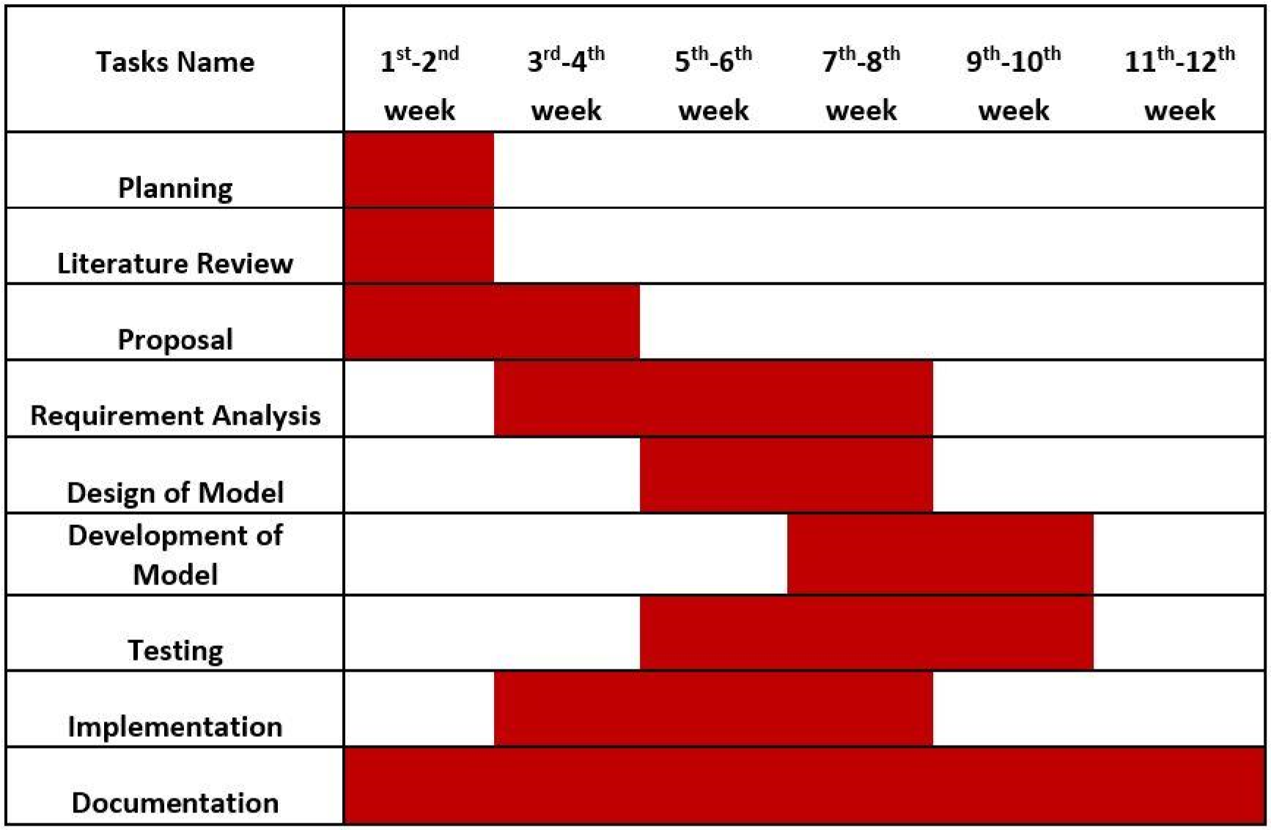

###### Figure 3: Gantt Chart of Lifestyle Store

#### 3.1.4 Data Modeling (Entity Relationship diagram)

An entity relationship model is a graphical representation of entities and their relationships to each other. An entity is a piece of data an object or concept about which data is stored and a relationship is how the data is shared between entities. Here, entities are Product, Users. Each entity consists of related attributes which describes the entity. This attribute describes each table or entities and relationship between the entities are showing how these entities are linked together.

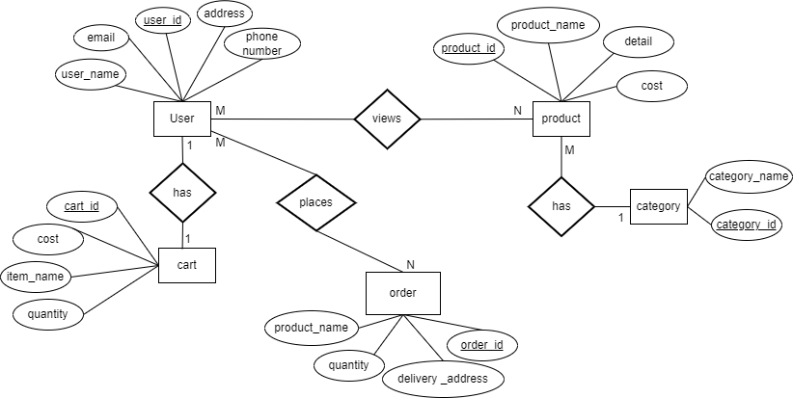

###### Figure 4: ER Diagram of LifeStyle Store

## 3.2 System Design

System design is the process of developing a strategy or blueprint for a complicated system that fits particular specifications. It entails developing the system's architecture, components, modules, interfaces, and data, as well as outlining how they interact with one another to deliver the intended functionality.

#### 3.2.1 Architectural Design

Architectural design is the structure of the system made. IEEE defines architectural design as “the process of defining a collection of hardware and software components and their interfaces to establish the framework for the development of a computer system.”

#### 3.2.2 Database Schema Design

A database schema is the skeleton structure that represents the logical view of the entire database. It defines how the data is organized and how the relations among them are associated. It formulates all the constraints that are to be applied on the data.

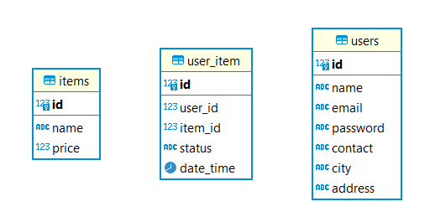

###### Figure 5: Database Schema for Lifestyle Store

#### 3.2.3 User Interface Design

The user interface is the front-end application view with which the user interacts in order to operate the system. This system has an interactive design that makes it simple to control the actors

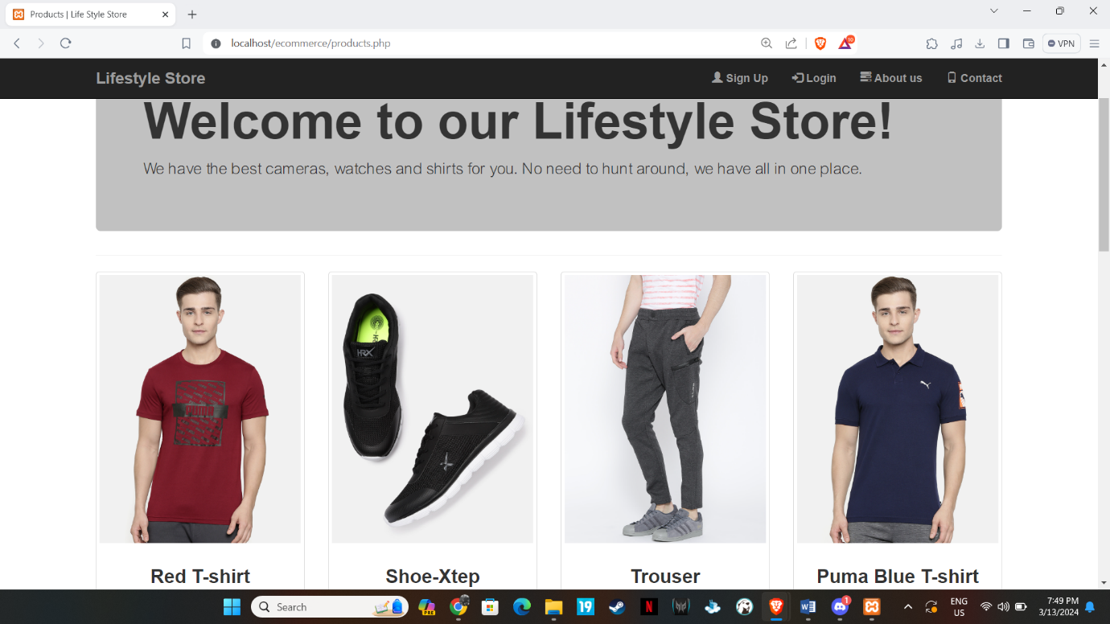

###### Figure 6: UI Design of Lifestyle Store

# CHAPTER FOUR: IMPLEMENTATION AND TESTING

## 4.1 Implementation

The implementation phase is the process of converting a system specification into an executable system. All the design and planning done initially is finally transformed into an actual solution to meet the requirements.

### 4.1.1 Tool Used

The frontend, backend tools and documentation tools used in making this system are:

1. **Front-End:**

For the front end, the initial design of each layout is constructed using HTML (Hyper Text Markup Language), CSS (Cascading Style Sheet) and Bootstrap in Visual Studio Code. The designs are also assisted with JavaScript.

1. **Back-End:**

For the back end, MySQL and PHP are used. PHP is used as the programming part of the web application whereas MySQL is used as the backend database technology for implementing the database.

1. **Documentation:**

* Microsoft Office: Whole proposal were prepared using Microsoft Office software.
* Draw.io: The diagrams of the system like DFD, SFD were designed on the Draw.io site.
* Canva: To make a Gantt chart.

###### 4.1.2 Implementation Details of Modules

Different modules are used for various purposes in this website:

**Registration module:** In this module, user registers to the system by providing user's email address, username and password. Email address provided by user is verified through verification code which is send via email.

**Login Module:** User provide user details to the system which is verified with the details present in database.

**Cart Module:** In this module, user can add products to the cart which can be further deleted.

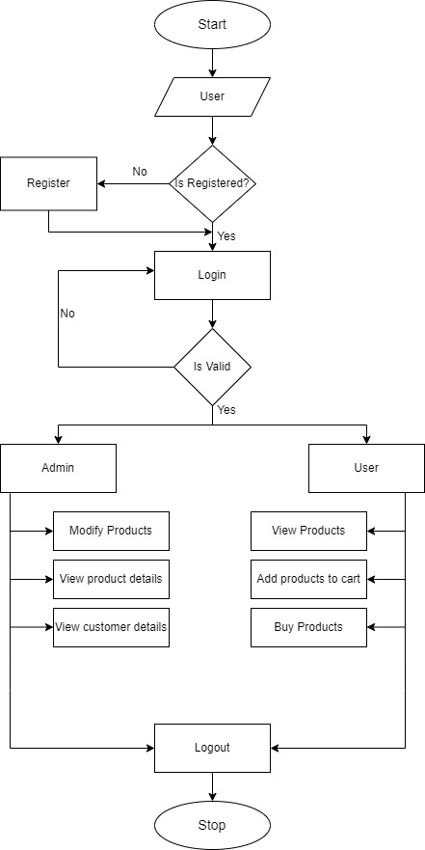

###### Figure 7: SFD of Lifestyle Store

## 4.2 Testing

All functions, procedures and modules were tested individually as unit. All the units were integrated as one and tested as a whole. Different testing methodologies were used to test modules.

#### 4.2.1 Test cases for Unit Testing

Various modules were tested individually to find any possible errors.

##### Table 1: Test for Failed User Registration (Wrong email format)

|  |  |
| --- | --- |
| **Test Case 1** | **Failed User Registration (Wrong email format)** |
| Input | Name: Sohesh Maharjan  Email: sohesh  Password: *****  Confirm Password: ***** |
| Expected  Output | Must Include @gmail.com or @yahoo.com. |

###### Table 2: Test for Failed User Registration (Unmatching Password)

|  |  |
| --- | --- |
| **Test Case 2** | **Failed User Registration (Password does not match)** |
| Input | Name: Sohesh Maharjan  Email: sohesh@gmail.com  Password: Sohesh123  Confirm Password: Sohesh1234 |
| Expected output | Password doesn’t match. |

##### Table 3: Test for Successful User Registration

|  |  |
| --- | --- |
| **Test Case 3** | **Successful User Registration** |
| Input | Email: hero@gmail.com  Username: hero  Password: Hero@123  Confirm Password:Hero@123 |
| Expected Output | Open Home Page. |

##### Table 4: Test for Successful User Login

|  |  |
| --- | --- |
| **Test Case 4** | **Successful User Login** |
| Input | Email: hero@gmail.com  Password: Hero@123 |
| Expected Output | Landing page entered. |

***Table 5: Test for Failed User Login (Wrong password or email)***

|  |  |
| --- | --- |
| **Test Case 5** | **Unsuccessful User Login (Wrong password)** |
| Input | Email: hero@gamil.com  Password: Hero123 |
| Expected  Result | Please enter correct username/password |

#### 4.2.2 Test Cases for System Testing

Various scenarios were tested, and it was made sure that all the models were integrated properly and were working.

##### Table 6: Test of the whole System

|  |  |
| --- | --- |
| **Test case** | **User registration, login, add to cart** |
| Input | User registration detail, Login details and Add to Cart |
| Expected Output | Product added to cart |
| Result | Product were added to cart |

# CHAPTER FIVE: CONCLUSION AND FUTURE RECOMMENDATIONS

## 5.1 Conclusion

The website was developed using PHP, MySQL, JavaScript, HTML and CSS. Any consumer can browse products, add, or remove a product from the cart and checkout to complete the purchase. The users can log in, with their information such as their email and password. Users can save delivery time for the buyers. Admin can add/edit and delete the product once placed on the site.

## 5.2 Future Recommendation

Some of the enhancement that can be made in the project in the future can be as follows:

* More categories can be added to the website.
* Various products can be added so that customers have wide range of variation to choose from.
* Related products can be implemented in coming future.
* Addition of admin panel.

# References

[1] SHEIN : Availabl: https://www.sheingroup.com/ .

[2] Canva. [Online]. Available: https://www.canva.com/

[3] Diagrams.net. [Online]. Available: https://app.diagrams.net/

# Appendices

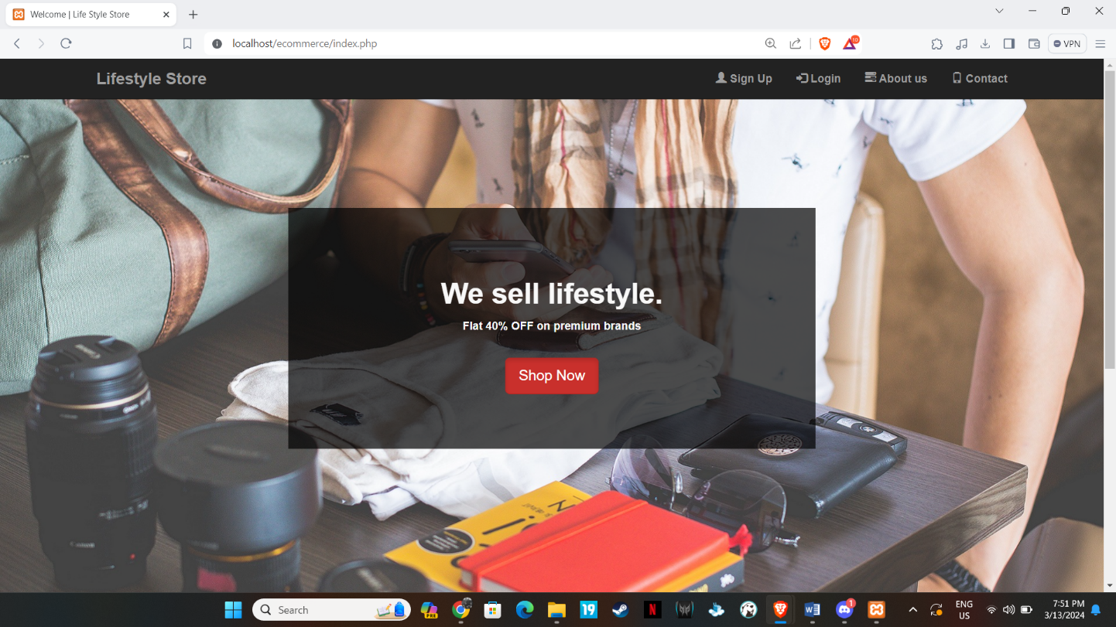

###### Figure 8: Home Page

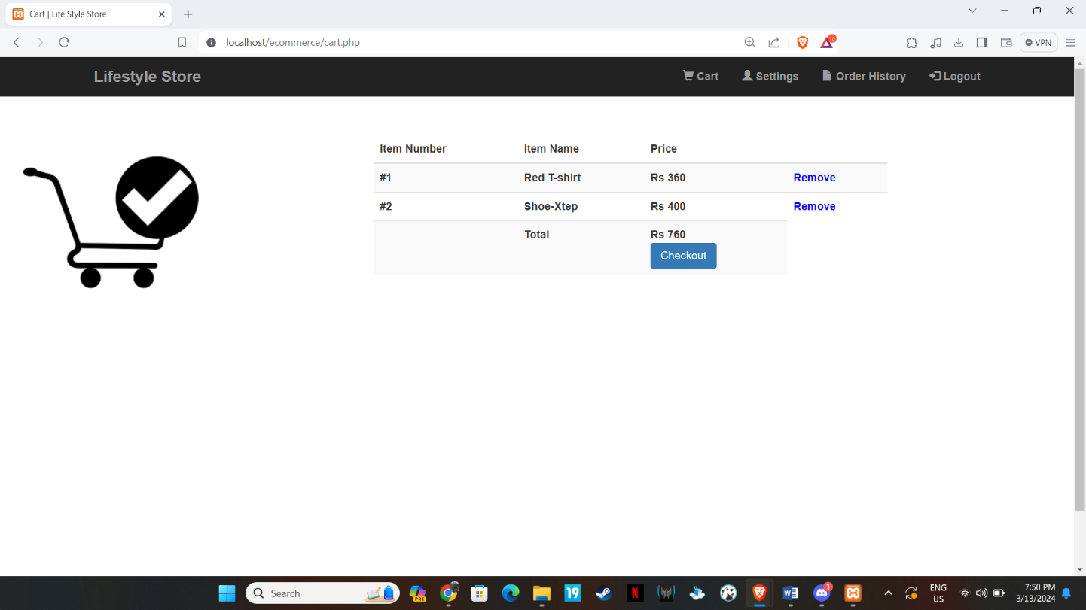

###### Figure 9: Cart

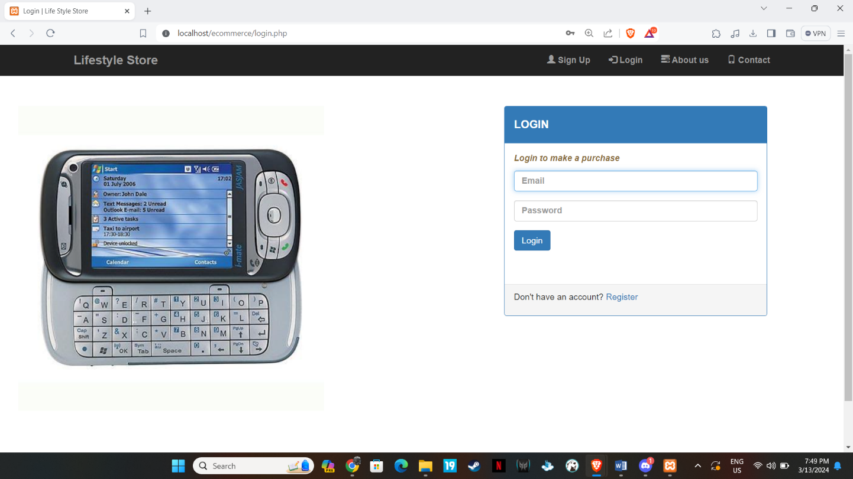

###### Figure 10: User Login